Chapter 2

Self-Review Exercises
2.1 Fill in the blanks in each of the following statements:

a) A(n)_{_______ begins the body of every method, and a(n)__}______ ends the body of every method.
b) You can use the _IF STATEMENT________ statement to make decisions.
c) _//________begins an end-of-line comment.
d)__Space ( )______ , _Tab(\t)_______and _Newline(\n)_______are called white space.
e) __keywords_______ are reserved for use by Java.
f) Java applications begin execution at method __Main______ .
g) Methods_System.out.print ()_______ ,__System.out.println( )_____ and__System.out.printf( )____ display information in a command window.

2.2 State whether each of the following is true or false. If false, explain why.
a) Comments cause the computer to print the text after the // on the screen when the program executes.
False.
💡 Explanation:
Comments in Java do not cause the computer to print anything on the screen when the program executes.
Anything written after // (a single-line comment) or between /* ... */ (a multi-line comment) is ignored by the Java compiler — it’s meant for humans reading the code, not for the computer to execute.

b) All variables must be given a type when they’re declared.
True.
💡 Explanation:
In Java, every variable must have a data type when it is declared. The type tells the compiler what kind of data the variable will hold — for example, an integer, a floating-point number, a character, a string, etc.

c) Java considers the variables number and NuMbEr to be identical.
False.
💡 Explanation:
Java is a case-sensitive programming language.
This means that variables with the same letters but different capitalization are treated as completely different identifiers.

d) The remainder operator (%) can be used only with integer operands.
False.
💡 Explanation:
Java is a case-sensitive programming language.
This means that variables with the same letters but different capitalization are treated as completely different identifiers.

e) The arithmetic operators *, /, %, + and - all have the same level of precedence.
False.
💡 Explanation:
In Java, the arithmetic operators do not all have the same level of precedence.
The order of precedence determines which operations are performed first when several appear in the same expression.

2.3 Write statements to accomplish each of the following tasks:
a) Declare variables c, thisIsAVariable, q76354 and number to be of type int.
int c, thisIsAVariable, q76354, number;
b) Prompt the user to enter an integer.
import java.util.Scanner; // Import the Scanner class

public class Main {
public static void main(String[] args) {
Scanner input = new Scanner(System.in); // Create a Scanner object
System.out.print("Enter an integer: "); // Prompt the user
int number = input.nextInt(); // Read the integer input
System.out.println("You entered: " + number); // Display the input
}
}
c) Input an integer and assign the result to int variable value. Assume Scanner variable input can be used to read a value from the keyboard.
int value = input.nextInt();
d) Print "This is a Java program" on one line in the command window. Use method System.out.println.
System.out.println("This is a Java program");
e) Print "This is a Java program" on two lines in the command window. The first line should end with Java. Use method System.out.printf and two %s format specifiers.
System.out.printf("%s%n%s", "This is a Java", "program");
f) If the variable number is not equal to 7, display "The variable number is not equal to 7”
if (number != 7) {
System.out.println("The variable number is not equal to 7");
}

2.4 Identify and correct the errors in each of the following statements:
a) if (c < 7); System.out.println("c is less than 7");
if (c < 7) {
System.out.println("c is less than 7");
}
b) if (c => 7) System.out.println("c is equal to or greater than 7");
if (c >= 7) {
System.out.println("c is equal to or greater than 7");
}

2.5 Write declarations, statements or comments that accomplish each of the following tasks:
a) State that a program will calculate the product of three integers.
// a) This program will calculate the product of three integers

import java.util.Scanner; // Required to use the Scanner class

public class ProductCalculator {
public static void main(String[] args) {
b) Create a Scanner called input that reads values from the standard input.
// b) Create a Scanner called input that reads values from the standard input
Scanner input = new Scanner(System.in);
c) Declare the variables x, y, z and result to be of type int.
Declare the variables x, y, z, and result to be of type int
int x, y, z, result;
d) Prompt the user to enter the first integer.
System.out.print("Enter the first integer: ");
e) Read the first integer from the user and store it in the variable x.
x = input.nextInt();
f) Prompt the user to enter the second integer.
System.out.print("Enter the second integer: ");
g) Read the second integer from the user and store it in the variable y.
y = input.nextInt();
h) Prompt the user to enter the third integer.
System.out.print("Enter the third integer: ");
i) Read the third integer from the user and store it in the variable z.
z = input.nextInt();
j) Compute the product of the three integers contained in variables x, y and z, and assign the result to the variable result.
result = x * y * z;
k) Use System.out.printf to display the message "Product is" followed by the value of the variable result.
System.out.printf("Product is %d%n", result);

2.6 Using the statements you wrote in Exercise 2.5, write a complete program that calculates and prints the product of three integers.
import java.util.Scanner; // Import the Scanner class for user input

public class ProductCalculator {
public static void main(String[] args) {

// Create a Scanner object to read input from the keyboard
Scanner input = new Scanner(System.in);

// Declare variables
int x, y, z, result;

// Prompt and read the first integer
System.out.print("Enter the first integer: ");
x = input.nextInt();

// Prompt and read the second integer
System.out.print("Enter the second integer: ");
y = input.nextInt();

// Prompt and read the third integer
System.out.print("Enter the third integer: ");
z = input.nextInt();

// Compute the product of the three integers
result = x * y * z;

// Display the product
System.out.printf("Product is %d%n", result);
}
}

Exercises
2.7 Fill in the blanks in each of the following statements:
a) _comments______ are used to document a program and improve its readability.
b) A decision can be made in a Java program with a(n)__IF STATEMENT_______ .
c) Calculations are normally performed by _ASSIGNMENT______ statements.
d) The arithmetic operators with the same precedence as multiplication are __DIVISION______ and ___MODULUS______ .
e) When parentheses in an arithmetic expression are nested, the _INNERMOST______ set of parentheses is evaluated first.
f) A location in the computer’s memory that may contain different values at various times throughout the execution of a program is called a(n) _VARIABLE___.
2.8 Write Java statements that accomplish each of the following tasks: a) Display the message "Enter an integer: ", leaving the cursor on the same line.
System.out.print("Enter an integer: ");
b) Assign the product of variables b and c to variable a.
a = b * c;
c) Use a comment to state that a program performs a sample payroll calculation.
// This program performs a sample payroll calculation
2.9 State whether each of the following is true or false. If false, explain why.
a) Java operators are evaluated from left to right.
False.
💡 Explanation:
Not all Java operators are evaluated strictly from left to right — it depends on operator precedence and associativity.

b) The following are all valid variable names: _under_bar_, m928134, t5, j7, her_sales$, his_$account_total, a, b$, c, z and z2.
TRUE
c) A valid Java arithmetic expression with no parentheses is evaluated from left to right.
False.
💡 Explanation:
Java evaluates arithmetic expressions based on operator precedence, not just left-to-right order.
For example:

d) The following are all invalid variable names: 3g, 87, 67h2, h22 and 2h.
False.
💡 Explanation:
Only the identifiers that begin with a digit are invalid.

2.10 Assuming that x=2 and y=3, what does each of the following statements display?
a) System.out.printf("x = %d%n", x);
System.out.printf("x = %d%n", x);
b) System.out.printf("Value of %d + %d is %d%n", x, x, (x + x));
System.out.printf("Value of %d + %d is %d%n", x, x, (x + x));
c) System.out.printf("x ="); d) System.out.printf("%d = %d%n", (x + y), (y + x));
System.out.printf("x =");
2.11 Which of the following Java statements contain variables whose values are modified?
a) p=i+j+k+ 7;
✅ Yes — variable p is modified.

b) System.out.println("variables whose values are modified");
No.
c) System.out.println("a = 5");
No.
d) value = input.nextInt();
Yes — variable value is modified.
2.12 Given that y = ax3 + 7, which of the following are correct Java statements for this equation?
a) y=a*x*x*x+ 7;
Correct.
This directly represents y=a×x3+7y = a \times x^3 + 7y=a×x3+7.
b) y = a * x * x * (x + 7);
Incorrect.
This means y=a×x2×(x+7)y = a \times x^2 \times (x + 7)y=a×x2×(x+7),
which expands to ax3+7ax2a x^3 + 7 a x^2ax3+7ax2 — not the same as ax3+7a x^3 + 7ax3+7
c) y = (a * x) * x * (x + 7);
Incorrect.
This gives ax2(x+7)=ax3+7ax2a x^2 (x + 7) = a x^3 + 7 a x^2ax2(x+7)=ax3+7ax2,
again not the same as ax3+7a x^3 + 7ax3+7.
d) y = (a * x) * x * x + 7;
Correct.
Parentheses don’t change the meaning — it’s equivalent to a×x3+7a \times x^3 + 7a×x3+7.
e) y = a * (x * x * x) + 7;
Correct.
This clearly means y=a×(x3)+7y = a \times (x^3) + 7y=a×(x3)+7
f) y = a * x * (x * x + 7);
Incorrect.
This gives ax(x2+7)=ax3+7axa x (x^2 + 7) = a x^3 + 7 a xax(x2+7)=ax3+7ax,
not ax3+7a x^3 + 7ax3+7.

2.13 State the order of evaluation of the operators in each of the following Java statements, and show the value of x after each statement is performed:
a) x = 7 + 3 * 6 / 2 - 1;

Order of evaluation:
- * and / have the same precedence — evaluated left to right.
- Then + and - are evaluated left to right.

Step-by-step:
- 3 * 6 → 18
- 18 / 2 → 9
- Substitute back: x = 7 + 9 - 1
- 7 + 9 → 16
- 16 - 1 → 15

b) x = 2 % 2 + 2 * 2 - 2 / 2;

Order of evaluation:
- %, *, / → same precedence, evaluated left to right
- Then +, - left to right.

Step-by-step:
- 2 % 2 → 0
- 2 * 2 → 4
- 2 / 2 → 1
- Substitute: x = 0 + 4 - 1
- 0 + 4 → 4
- 4 - 1 → 3

c) x=(3 * 9 * (3 + (9 * 3 / (3))));

Order of evaluation:
- Evaluate innermost parentheses first: (3) → just 3
- Then inside the next parentheses: (9 * 3 / (3))
  - 9 * 3 → 27
  - 27 / 3 → 9
- Now the expression becomes:
x = (3 * 9 * (3 + 9));
- Inside parentheses: (3 + 9) → 12
- Now: x = 3 * 9 * 12
- Evaluate left to right:
  - 3 * 9 → 27
  - 27 * 12 → 324

2.14 Write an application that displays the numbers 1 to 4 on the same line, with each pair of adjacent numbers separated by one space. Use the following techniques:
a) Use one System.out.println statement.
System.out.println("1 2 3 4");
b) Use four System.out.print statements.
System.out.print("1 ");
System.out.print("2 ");
System.out.print("3 ");
System.out.print("4");
c) Use one System.out.printf statement. www.EBooksWorld.ir 68 Chapter 2 Introduction to Java Applications; Input/Output and Operators
System.out.printf("%d %d %d %d", 1, 2, 3, 4);
2.15 (Arithmetic) Write an application that asks the user to enter two integers, obtains them from the user and prints their sum, product, difference and quotient (division). Use the techniques shown in Fig. 2.7.
import java.util.Scanner; // Import the Scanner class for input

public class ArithmeticOperations {
public static void main(String[] args) {
// Create Scanner object for user input
Scanner input = new Scanner(System.in);

// Prompt the user for two integers
System.out.print("Enter first integer: ");
int num1 = input.nextInt();

System.out.print("Enter second integer: ");
int num2 = input.nextInt();

// Perform arithmetic operations
int sum = num1 + num2;
int difference = num1 - num2;
int product = num1 * num2;
int quotient = num1 / num2; // integer division

// Display the results
System.out.printf("Sum: %d%n", sum);
System.out.printf("Difference: %d%n", difference);
System.out.printf("Product: %d%n", product);
System.out.printf("Quotient: %d%n", quotient);
}
}
2.16 (Comparing Integers) Write an application that asks the user to enter two integers, obtains them from the user and displays the larger number followed by the words "is larger". If the numbers are equal, print the message "These numbers are equal". Use the techniques shown in Fig.
import java.util.Scanner; // Import the Scanner class

public class CompareIntegers {
public static void main(String[] args) {
// Create a Scanner object for input
Scanner input = new Scanner(System.in);

// Prompt the user for two integers
System.out.print("Enter first integer: ");
int num1 = input.nextInt();

System.out.print("Enter second integer: ");
int num2 = input.nextInt();

// Compare the two integers
if (num1 > num2) {
System.out.printf("%d is larger%n", num1);
}
else if (num2 > num1) {
System.out.printf("%d is larger%n", num2);
}
else {
System.out.println("These numbers are equal");
}
}
}
2.15. 2.17 (Arithmetic, Smallest and Largest) Write an application that inputs three integers from the user and displays the sum, average, product, smallest and largest of the numbers. Use the techniques shown in Fig. 2.15. [Note: The calculation of the average in this exercise should result in an integer representation of the average. So, if the sum of the values is 7, the average should be 2, not 2.3333….]
import java.util.Scanner; // Import Scanner class for user input

public class ArithmeticSmallestLargest {
public static void main(String[] args) {
Scanner input = new Scanner(System.in);

// Prompt the user to enter three integers
System.out.print("Enter first integer: ");
int num1 = input.nextInt();

System.out.print("Enter second integer: ");
int num2 = input.nextInt();

System.out.print("Enter third integer: ");
int num3 = input.nextInt();

// Calculate sum, average, and product
int sum = num1 + num2 + num3;
int average = sum / 3; // Integer division
int product = num1 * num2 * num3;

// Initialize smallest and largest with the first number
int smallest = num1;
int largest = num1;

// Compare to find the smallest
if (num2 < smallest)
smallest = num2;
if (num3 < smallest)
smallest = num3;

// Compare to find the largest
if (num2 > largest)
largest = num2;
if (num3 > largest)
largest = num3;

// Display results
System.out.printf("Sum is %d%n", sum);
System.out.printf("Average is %d%n", average);
System.out.printf("Product is %d%n", product);
System.out.printf("Smallest is %d%n", smallest);
System.out.printf("Largest is %d%n", largest);
}
}
2.18 (Displaying Shapes with Asterisks) Write an application that displays a box, an oval, an arrow and a diamond using asterisks (*), as follows:
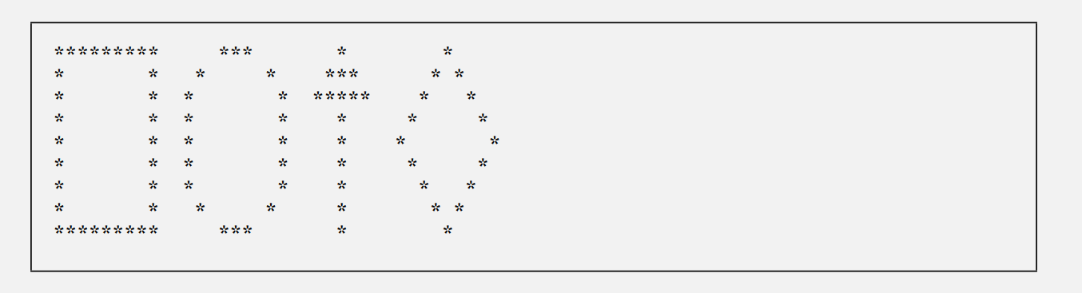
public class DisplayingShapes {
public static void main(String[] args) {

System.out.println("********* *** * *");
System.out.println("* * * * *** * *");
System.out.println("* * * * ***** * *");
System.out.println("* * * * * * *");
System.out.println("* * * * * * *");
System.out.println("* * * * * * *");
System.out.println("* * * * * * *");
System.out.println("* * * * * * *");
System.out.println("********* *** * *");
}
}
2.19 What does the following code print? System.out.printf("*%n**%n***%n****%n*****%n");
This code prints a simple triangle of asterisks, with each line adding one more * than the previous line.

2.20 What does the following code print?
System.out.println("*"); System.out.println("***"); System.out.println("*****");
System.out.println("****");
System.out.println("**");
The code prints a pattern of asterisks shaped like an irregular triangle or diamond top, with the longest line (*****) in the middle.

2.21 What does the following code print?
System.out.print("*"); System.out.print("***");
System.out.print("*****");
System.out.print("****");
System.out.println("**");
the program prints all stars on the same line, then ends with a newline.
2.22 What does the following code print?
System.out.print("*");
System.out.println("***");
System.out.println("*****");
System.out.print("****");
System.out.println("**");
• The first print and println combine on the same line.
• The next println starts a new line.
• The last two statements combine again before the final newline.

2.23 What does the following code print? System.out.printf("%s%n%s%n%s%n", "*", "***", "*****");
This code prints three lines of asterisks — one, three, and five — each on its own line
2.24 (Largest and Smallest Integers) Write an application that reads five integers and determines and prints the largest and smallest integers in the group. Use only the programming techniques you learned in this chapter.
import java.util.Scanner; // Import Scanner class for input

public class LargestAndSmallest {
public static void main(String[] args) {
Scanner input = new Scanner(System.in);

// Prompt the user to enter five integers
System.out.print("Enter first integer: ");
int num1 = input.nextInt();

System.out.print("Enter second integer: ");
int num2 = input.nextInt();

System.out.print("Enter third integer: ");
int num3 = input.nextInt();

System.out.print("Enter fourth integer: ");
int num4 = input.nextInt();

System.out.print("Enter fifth integer: ");
int num5 = input.nextInt();

// Initialize smallest and largest with the first number
int smallest = num1;
int largest = num1;

// Compare each number to find smallest and largest
if (num2 < smallest)
smallest = num2;
if (num3 < smallest)
smallest = num3;
if (num4 < smallest)
smallest = num4;
if (num5 < smallest)
smallest = num5;

if (num2 > largest)
largest = num2;
if (num3 > largest)
largest = num3;
if (num4 > largest)
largest = num4;
if (num5 > largest)
largest = num5;

// Display results
System.out.printf("Largest number is %d%n", largest);
System.out.printf("Smallest number is %d%n", smallest);
}
}
2.25 (Odd or Even) Write an application that reads an integer and determines and prints whether it’s odd or even. [Hint: Use the remainder operator. An even number is a multiple of 2. Any multiple of 2 leaves a remainder of 0 when divided by 2.]
import java.util.Scanner; // Import Scanner for input

public class OddOrEven {
public static void main(String[] args) {
Scanner input = new Scanner(System.in);

// Prompt the user to enter an integer
System.out.print("Enter an integer: ");
int number = input.nextInt();

// Determine whether the number is even or odd
if (number % 2 == 0)
System.out.printf("%d is even.%n", number);
else
System.out.printf("%d is odd.%n", number);
}
}
2.26 (Multiples) Write an application that reads two integers, determines whether the first is a multiple of the second and prints the result. [Hint: Use the remainder operator.]
import java.util.Scanner; // Import Scanner class for user input

public class Multiples {
public static void main(String[] args) {
Scanner input = new Scanner(System.in);

// Prompt the user to enter two integers
System.out.print("Enter first integer: ");
int firstNumber = input.nextInt();

System.out.print("Enter second integer: ");
int secondNumber = input.nextInt();

// Determine whether the first is a multiple of the second
if (firstNumber % secondNumber == 0)
System.out.printf("%d is a multiple of %d.%n", firstNumber, secondNumber);
else
System.out.printf("%d is not a multiple of %d.%n", firstNumber, secondNumber);
}
}
2.27 (Checkerboard Pattern of Asterisks) Write an application that displays a checkerboard pattern, as follows:
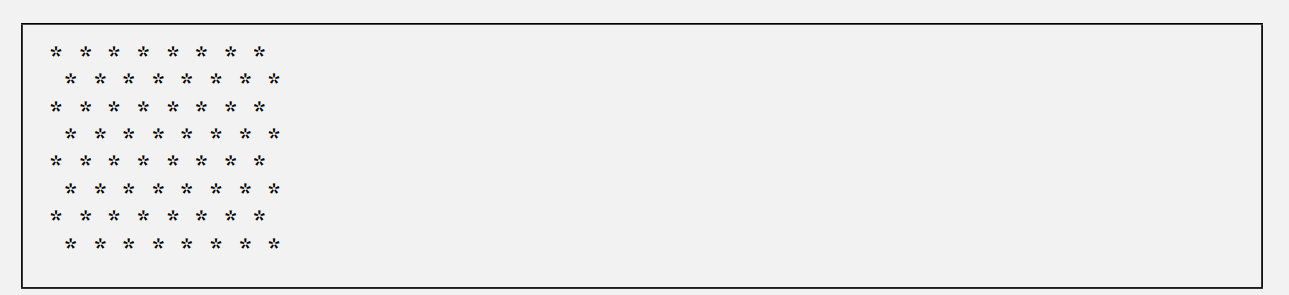
public class CheckerboardPattern {
public static void main(String[] args) {

System.out.println("* * * * * * * *");
System.out.println(" * * * * * * * *");
System.out.println("* * * * * * * *");
System.out.println(" * * * * * * * *");
System.out.println("* * * * * * * *");
System.out.println(" * * * * * * * *");
System.out.println("* * * * * * * *");
System.out.println(" * * * * * * * *");
}
}
2.28 (Diameter, Circumference and Area of a Circle) Here’s a peek ahead. In this chapter, you learned about integers and the type int. Java can also represent floating-point numbers that contain decimal points, such as 3.14159. Write an application that inputs from the user the radius of a circle as an integer and prints the circle’s diameter, circumference and area using the floating-point value 3.14159 for π. Use the techniques shown in Fig. 2.7. [Note: You may also use the predefined constant Math.PI for the value of π. This constant is more precise than the value 3.14159. Class Math is defined in package java.lang. Classes in that package are imported automatically, so you do not need to import class Math to use it.] Use the following formulas (r is the radius): diameter = 2r circumference = 2πr area = πr2 Do not store the results of each calculation in a variable. Rather, specify each calculation as the value that will be output in a System.out.printf statement. The values produced by the circumference and area calculations are floating-point numbers. Such values can be output with the format specifier %f in a System.out.printf statement.
import java.util.Scanner; // Import Scanner class for input

public class CircleCalculations {
public static void main(String[] args) {
Scanner input = new Scanner(System.in);

// Prompt user for radius
System.out.print("Enter the radius of the circle as an integer: ");
int radius = input.nextInt();

// Display results directly inside printf without storing in extra variables
System.out.printf("Diameter is %d%n", (2 * radius));
System.out.printf("Circumference is %.2f%n", (2 * Math.PI * radius));
System.out.printf("Area is %.2f%n", (Math.PI * radius * radius));
}
}

2.29 (Integer Value of a Character) Here’s another peek ahead. In this chapter, you learned about integers and the type int. Java can also represent uppercase letters, lowercase letters and a considerable variety of special symbols. Every character has a corresponding integer representation. The set of characters a computer uses together with the corresponding integer representations for those characters is called that computer’s character set. You can indicate a character value in a program simply by enclosing that character in single quotes, as in 'A'. You can determine a character’s integer equivalent by preceding that character with (int), as in (int) 'A' An operator of this form is called a cast operator. (You’ll learn about cast operators in Chapter 3.) The following statement outputs a character and its integer equivalent: System.out.printf("The character %c has the value %d%n", 'A', ((int) 'A')); When the preceding statement executes, it displays the character A and the value 65 (from the Unicode® character set) as part of the string. The format specifier %c is a placeholder for a character (in this case, the character 'A'). Using statements similar to the one shown earlier in this exercise, write an application that displays the integer equivalents of some uppercase letters, lowercase letters, digits and special symbols. Display the integer equivalents of the following: ABCabc012$*+/ and the blank character.
public class CharacterIntegerValues {
public static void main(String[] args) {

System.out.printf("The character %c has the value %d%n", 'A', ((int) 'A'));
System.out.printf("The character %c has the value %d%n", 'B', ((int) 'B'));
System.out.printf("The character %c has the value %d%n", 'C', ((int) 'C'));
System.out.printf("The character %c has the value %d%n", 'a', ((int) 'a'));
System.out.printf("The character %c has the value %d%n", 'b', ((int) 'b'));
System.out.printf("The character %c has the value %d%n", 'c', ((int) 'c'));
System.out.printf("The character %c has the value %d%n", '0', ((int) '0'));
System.out.printf("The character %c has the value %d%n", '1', ((int) '1'));
System.out.printf("The character %c has the value %d%n", '2', ((int) '2'));
System.out.printf("The character %c has the value %d%n", '$', ((int) '$'));
System.out.printf("The character %c has the value %d%n", '*', ((int) '*'));
System.out.printf("The character %c has the value %d%n", '+', ((int) '+'));
System.out.printf("The character %c has the value %d%n", '/', ((int) '/'));
System.out.printf("The character (space) has the value %d%n", ((int) ' '));
}
}
2.30 (Separating the Digits in an Integer) Write an application that inputs one number consisting of five digits from the user, separates the number into its individual digits and prints the digits separated from one another by three spaces each. For example, if the user types in the number 42339, the program should print
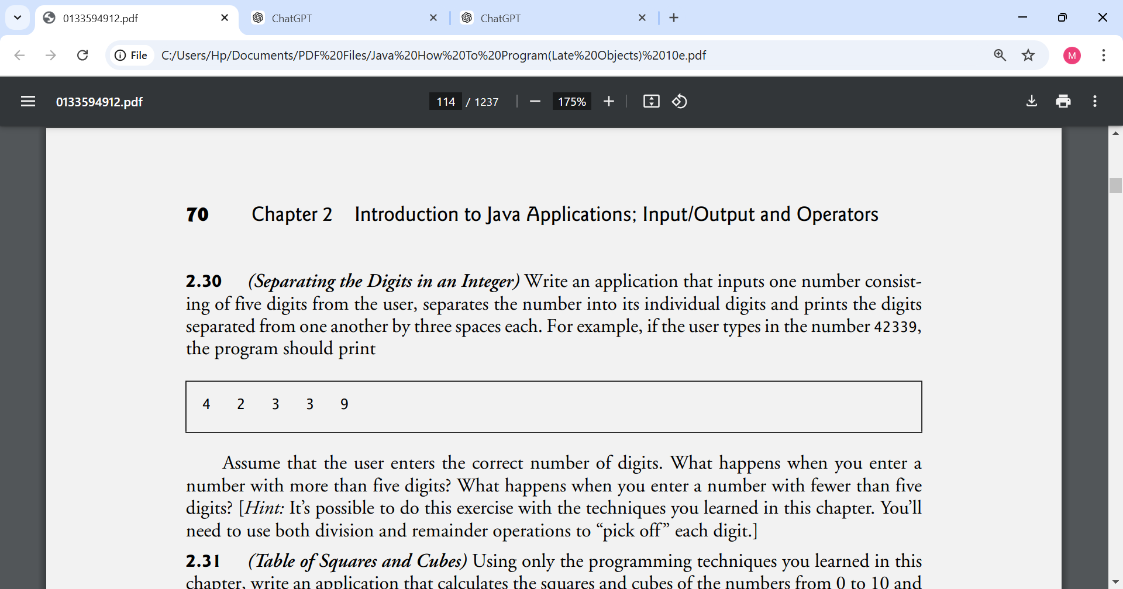

Assume that the user enters the correct number of digits. What happens when you enter a number with more than five digits? What happens when you enter a number with fewer than five digits? [Hint: It’s possible to do this exercise with the techniques you learned in this chapter. You’ll need to use both division and remainder operations to “pick off ” each digit.]
import java.util.Scanner;

public class SeparateDigits {
public static void main(String[] args) {
Scanner input = new Scanner(System.in);

System.out.print("Enter a five-digit integer: ");
int number = input.nextInt();

// Extract digits using division and remainder
int digit1 = number / 10000; // first digit
int digit2 = (number / 1000) % 10; // second digit
int digit3 = (number / 100) % 10; // third digit
int digit4 = (number / 10) % 10; // fourth digit
int digit5 = number % 10; // fifth digit

// Print digits separated by three spaces
System.out.printf("%d %d %d %d %d%n", digit1, digit2, digit3, digit4, digit5);
}
}

2.31 (Table of Squares and Cubes) Using only the programming techniques you learned in this chapter, write an application that calculates the squares and cubes of the numbers from 0 to 10 and prints the resulting values in table format, as shown below.
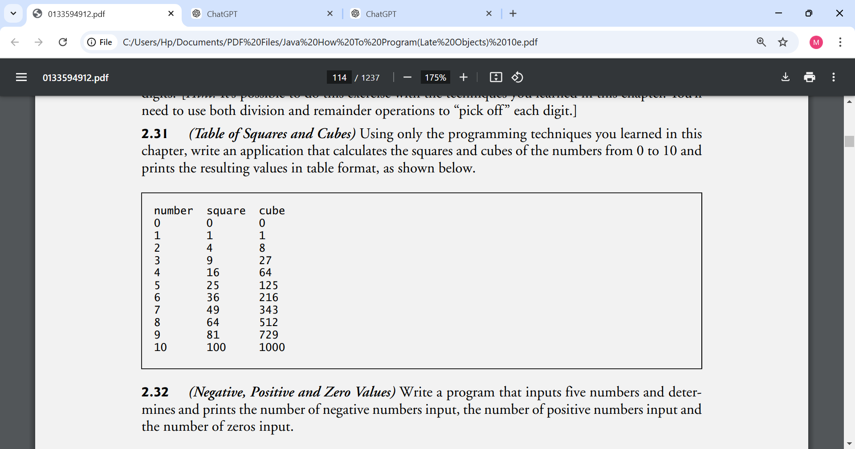
public class TableOfSquaresAndCubes {
public static void main(String[] args) {

// Print table header
System.out.println("number square cube");
System.out.println("=======================");

// Print table rows (0 to 10)
System.out.printf("%d %d %d%n", 0, (0 * 0), (0 * 0 * 0));
System.out.printf("%d %d %d%n", 1, (1 * 1), (1 * 1 * 1));
System.out.printf("%d %d %d%n", 2, (2 * 2), (2 * 2 * 2));
System.out.printf("%d %d %d%n", 3, (3 * 3), (3 * 3 * 3));
System.out.printf("%d %d %d%n", 4, (4 * 4), (4 * 4 * 4));
System.out.printf("%d %d %d%n", 5, (5 * 5), (5 * 5 * 5));
System.out.printf("%d %d %d%n", 6, (6 * 6), (6 * 6 * 6));
System.out.printf("%d %d %d%n", 7, (7 * 7), (7 * 7 * 7));
System.out.printf("%d %d %d%n", 8, (8 * 8), (8 * 8 * 8));
System.out.printf("%d %d %d%n", 9, (9 * 9), (9 * 9 * 9));
System.out.printf("%d %d %d%n", 10, (10 * 10), (10 * 10 * 10));
}
}
2.32 (Negative, Positive and Zero Values) Write a program that inputs five numbers and determines and prints the number of negative numbers input, the number of positive numbers input and the number of zeros input.
import java.util.Scanner;

public class NegativePositiveZero {
public static void main(String[] args) {
Scanner input = new Scanner(System.in);

int number1, number2, number3, number4, number5;
int positiveCount = 0;
int negativeCount = 0;
int zeroCount = 0;

System.out.print("Enter first number: ");
number1 = input.nextInt();

System.out.print("Enter second number: ");
number2 = input.nextInt();

System.out.print("Enter third number: ");
number3 = input.nextInt();

System.out.print("Enter fourth number: ");
number4 = input.nextInt();

System.out.print("Enter fifth number: ");
number5 = input.nextInt();

// Check first number
if (number1 > 0)
positiveCount++;
else if (number1 < 0)
negativeCount++;
else
zeroCount++;

// Check second number
if (number2 > 0)
positiveCount++;
else if (number2 < 0)
negativeCount++;
else
zeroCount++;

// Check third number
if (number3 > 0)
positiveCount++;
else if (number3 < 0)
negativeCount++;
else
zeroCount++;

// Check fourth number
if (number4 > 0)
positiveCount++;
else if (number4 < 0)
negativeCount++;
else
zeroCount++;

// Check fifth number
if (number5 > 0)
positiveCount++;
else if (number5 < 0)
negativeCount++;
else
zeroCount++;

// Display results
System.out.printf("%nNumb
Making a Difference
2.33 (Body Mass Index Calculator) We introduced the body mass index (BMI) calculator in Exercise 1.10. The formulas for calculating BMI are
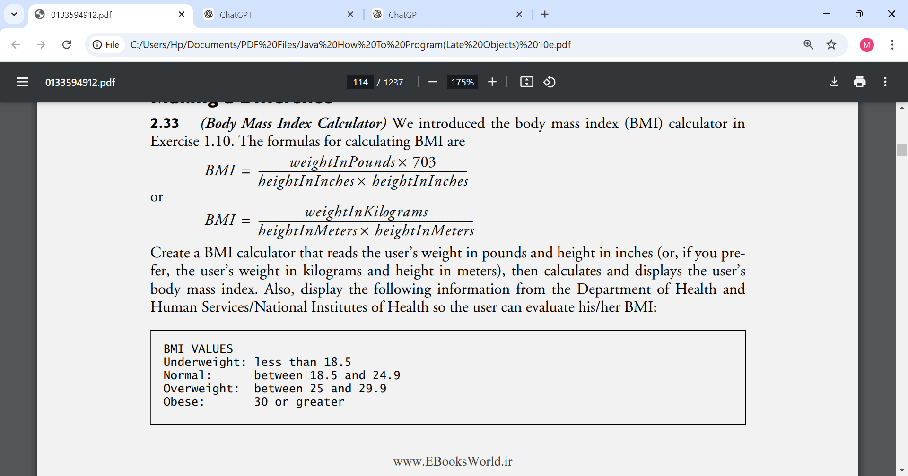
Create a BMI calculator that reads the user’s weight in pounds and height in inches (or, if you prefer, the user’s weight in kilograms and height in meters), then calculates and displays the user’s body mass index. Also, display the following information from the Department of Health and Human Services/National Institutes of Health so the user can evaluate his/her BMI:
[Note: In this chapter, you learned to use the int type to represent whole numbers. The BMI calculations when done with int values will both produce whole-number results. In Chapter 3, you’ll learn to use the double type to represent numbers with decimal points. When the BMI calculations are performed with doubles, they’ll both produce numbers with decimal points—these are called “floating-point” numbers.]
import java.util.Scanner;

public class BMICalculator {
public static void main(String[] args) {
Scanner input = new Scanner(System.in);

// Ask the user for weight and height
System.out.print("Enter your weight in pounds: ");
int weight = input.nextInt();

System.out.print("Enter your height in inches: ");
int height = input.nextInt();

// BMI formula for imperial units:
// BMI = (weight in pounds * 703) / (height in inches)^2
int bmi = (weight * 703) / (height * height);

// Display result
System.out.printf("%nYour Body Mass Index (BMI) is %d%n%n", bmi);

// Display BMI categories
System.out.println("BMI VALUES");
System.out.println("Underweight: less than 18.5");
System.out.println("Normal: between 18.5 and 24.9");
System.out.println("Overweight: between 25 and 29.9");
System.out.println("Obese: 30 or greater");
}
}

2.34 (World Population Growth Calculator) Use the web to determine the current world population and the annual world population growth rate. Write an application that inputs these values, then displays the estimated world population after one, two, three, four and five years.
import java.util.Scanner;

public class WorldPopulationGrowth {
public static void main(String[] args) {
Scanner input = new Scanner(System.in);

System.out.print("Enter current world population (integer): ");
int population = input.nextInt();

System.out.print("Enter annual growth rate (e.g., 0.90 for 0.90%): ");
double rate = input.nextDouble();

System.out.println();
System.out.println("Estimated world population after each year:");
System.out.printf("After 1 year: %d%n", (int)(population * (1 + rate)));
System.out.printf("After 2 years: %d%n", (int)(population * Math.pow(1 + rate, 2)));
System.out.printf("After 3 years: %d%n", (int)(population * Math.pow(1 + rate, 3)));
System.out.printf("After 4 years: %d%n", (int)(population * Math.pow(1 + rate, 4)));
System.out.printf("After 5 years: %d%n", (int)(population * Math.pow(1 + rate, 5)));
}
}

2.35 (Car-Pool Savings Calculator) Research several car-pooling websites. Create an application that calculates your daily driving cost, so that you can estimate how much money could be saved by carpooling, which also has other advantages such as reducing carbon emissions and reducing traffic congestion. The application should input the following information and display the user’s cost per day of driving to work:
a) Total miles driven per day.
b) Cost per gallon of gasoline.
c) Average miles per gallon.
d) Parking fees per day.
e) Tolls per day
import java.util.Scanner;

public class CarPoolSavingsCalculator {
public static void main(String[] args) {
Scanner input = new Scanner(System.in);

double totalMiles; // total miles driven per day
double costPerGallon; // cost of a gallon of gas
double milesPerGallon; // average miles per gallon
double parkingFees; // parking fees per day
double tolls; // tolls per day
double dailyCost; // total daily cost

// Get user input
System.out.print("Enter total miles driven per day: ");
totalMiles = input.nextDouble();

System.out.print("Enter cost per gallon of gasoline: ");
costPerGallon = input.nextDouble();

System.out.print("Enter average miles per gallon: ");
milesPerGallon = input.nextDouble();

System.out.print("Enter parking fees per day: ");
parkingFees = input.nextDouble();

System.out.print("Enter tolls per day: ");
tolls = input.nextDouble();

// Calculate total cost per day
dailyCost = (totalMiles / milesPerGallon) * costPerGallon + parkingFees + tolls;

// Display result
System.out.printf("%nYour daily driving cost is: $%.2f%n"

